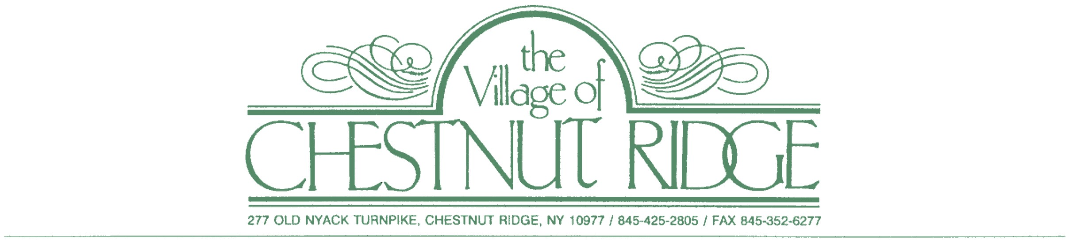

**ARB PUBLIC MEETING**

**VILLAGE OF CHESTNUT RIDGE**

**February 25, 2025,** **8:00 pm**

**AGENDA**

1. **5 Lark Lane- Public Hearing**

There is currently a single family to be demolished. The applicant is proposing a new single-family house. This single family will have 2 stories plus a basement with an attached garage. The owner is building his house for his family in a modern fashion. The proposed square footage is as following: Garage 489.4 sf, First Floor 3136.6 sf, Second Floor 2788.9 sf, Total for FAR 5925.5 sf.

Tax Map Designation Section: 62.8 Block: 2 Lots: 34 Zone: R-25

1. **4 Eastbourne Dr- Public Hearing**

There is currently a single family to be demolished. The applicant is proposing a new single-family house. This single family will have 2 stories plus a basement with an attached garage. The owner is building his house for his family in a modern fashion. The proposed square footage is as following: Garage 265 sf, First Floor 2887 sf, Second Floor 2433 sf, Total for FAR 5320 sf.

Tax Map Designation Section: 63.13 Block: 2 Lots: 46 Zone: R-25

*THE ORDER OF PROJECTS MAY NOT BE HEARD IN THE ORDER LISTED ABOVE AS IT IS THE SOLE DISCRETION OF THE ARCHITECTURAL REVIEW BOARD.*

*A $250.00 APPEARANCE FEE MUST BE PAID IN ADVANCE OF A SCHEDULED MEETING APPEARANCE TO ENABLE AN APPLICANT TO APPEAR. ALL OTHER FEES AS WELL AS ESCROW REPLENISHMENT WHEN REQUIRED MUST ALSO BE UP TO DATE.*